**PSY 6302 Assignment 2**

Install and load the following packages: tidyr, dplyr, magrittr, ggplot2, readxl, data.table, corrplot

Download and load the dataset, Beer Goggles, from the online JASP data repository. <https://johnnydoorn.github.io/DataLibraryBookdown/myChapters/chapter_3.html>

Description: This data set, "Beer Goggles", provides median attractiveness ratings of 50 attractive or unattractive faces after consuming different amounts of alcohol.

Variables:

* FaceType - Attractiveness of the rated faces (`0' = unattractive, `1' = attractive).
* Alcohol - Amount of alcohol consumed (`0' = Placebo group with 500 ml of non-alcoholic beer, `1' = Low-dose group with 500 ml of average strength beer (4% ABV), `2' = High-dose group with 500 ml of strong beer (7% ABV).
* Attractiveness - Median of the 50 attractiveness ratings on a scale from 0 (``pass me a paper bag'') to 10 (``pass me their phone number'').

More information about this dataset is provided in the online data repository resources.

Complete and submit all sections below.

**Section 1 (4pts)**. Examine the basic structure and descriptive statistics of all variables in your dataset, appropriately for each variable's data type (categorical vs continuous). Report results in 2-3 sentences: e.g., "*Variable A was categorical with N = N1 people in group 1 and N = N2 people in group 2. Variable B was continuous and relatively normally distributed with a mean of M = 100 and standard deviation of SD = 10.*”

**Section 2 (2pts)**. Examine the correlation between all three variables, using Spearman’s correlation. Use the Help tab as needed. Report your code below.

**Section 3 (2pts)**. Visualize the relationship between face type, alcohol, and attractiveness, using different colors to reflect the different factor values of alcohol. Report your code below.

**Section 4 (2pts)**. Visualize the relationship between alcohol and attractiveness, faceted by face type. Report your code below.

**Section 5 (2pts)**. Using the graph in Section 4, add appropriate labels for Face Type, using R code. Report your code below.

**Section 6 (2pts)**. Save your figure using code. Google how to do this and see if it works. Report your code below.

**Section 7 (4pts)**. Write 2-3 sentences explaining the concepts of internal and external validity.

**Section 8 (4pts)**. Relate the concepts of internal and external validity to causal relationships and experimental design in 2-3 sentences.

**Section 9 (4pts)**. Choose a topic in an area of your choice. Write a short (no more than 7 sentences) problem statement using logical syllogism (described below).

Syllogism is a “deductive scheme of a format argument consisting of major and minor premise and conclusion” (Merriam-Webster). Logical syllogism applied to a problem statement has two major components.

First, the problem.

1. Major Premise: Axiomatic, something that is known to be true or thoroughly documented.
2. Minor Premise: Either axiomatic or thoroughly documents; presents a conflict with major premise. There should be some tension between 1 and 2.
3. Conclusion: State the problem that arises from the tension, that needs to be resolved.

Next, the statement on how to resolve the problem.

1. Major premise: same as the conclusion (3) from the problem.
2. Minor premise: Ameliorating statement. The resolve to solve, “If such and such were done it would solve this problem.”
3. Conclusions: Promissory statement: “In this study we propose to solve this problem by…”

An example of logical syllogism is: 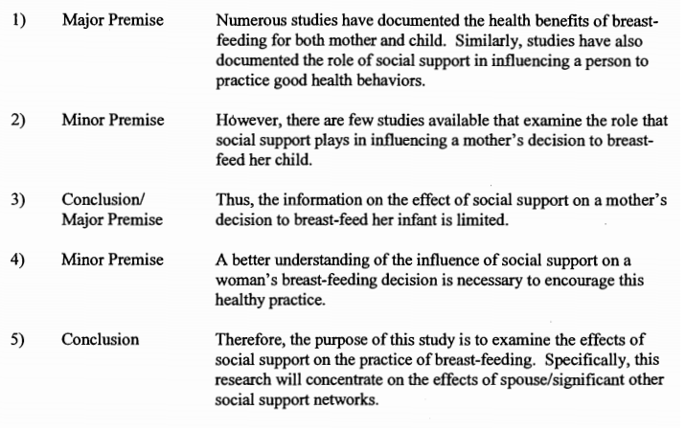

**Section 10 (4pts)**. Reflect on your problem statement. What threats to internal validity, external validity, statistical conclusion validity and/or construct validity do you anticipate and how will you resolve or interpret these threats? Will they impact your ability to discuss your research in the context of causation?